**Healthcare Monitoring System using IOT**

*Submitted in partial fulfillment of the requirements*

*for the degree of*

*Bachelor of Engineering*

Synopsis Report - Stage-II *by*

**Bhushan Koli**

**Roll No.32**

**Twinkle Mahajan**

**Roll No.38**

**Keval Rothe**

**Roll No.45**

**Krishna Khilare**

**Roll No.30**

*Under the Supervision of*

**Prof.Poonam .B.Lad**



**DEPARTMENT OF INFORMATION TECHNOLOGY**

**KONKAN GYANPEETH COLLEGE OF ENGINEERING**

KARJAT-410201

December 2020

# Certificate

This is to certify that the project entitled **Healthcare Monitoring System using IOT** is a bonafide work of **Bhushan Koli(Roll No.32),Twinkle Mahajan(Roll No.38),Keval Rothe(Roll No.45),Krishna Khilare(Roll No.30)** submitted to the University of Mumbai in partial fulfillment of the requirement for the award of the degree of **Undergraduate** in **DE-PARTMENT OF INFORMATION TECHNOLOGY**.

**Supervisor/Guide**

Prof.P.B.LAD

Department of Information Technology

### Head of Department Principal

//Dr.Anil S.Kale Dr.M.J.LENGARE

Department of Information Technology Konkan Gyanpeeth College of Engineering

# Project Report Approval

This project report entitled **Healthcare Monitoring System using IOT** by **Bhushan Koli (Roll No. 32),Twinkle Mahajan(Roll No. 38),Keval Rothe(Roll No.45),Krishna Khilare(Roll No.30)** is approved for the degree of **DEPARTMENT OF INFORMATION TECHNOLOGY**.

**Examiners**

**1.……………….**

**2.………………..**

**Date:**

**Place:**

# Declaration

I declare that this written submission represents my ideas in my own words and where others’ ideas or words have been included, I have adequately cited and referenced the original sources. I also declare that I have adhered to all principles of academic honesty and integrity and have not misrepresented or fabricated or falsified any idea/data/fact/source in my submission. I understand that any violation of the above will be cause for disciplinary action by the Institute and can also evoke penal action from the sources which have thus not been properly cited or from whom proper permission has not been taken when needed.

**Signature**

**(Bhushan Koli) Roll No 32**

### Signature

**(Twinkle Mahajan) Roll No 38**

**Signature (Keval Rothe) Roll No 45**

**Signature**

**(Krishna Khilare) Roll No 30**

**Date.**

# Abstract

The near about 20% of the total population loses their lives due to interrupted health monitoring system i.e. in most of the hospitals, doctor visits patients either in morning shift or in evening shift or in both shifts. What happens if patient's health becomes critical in between that interval or when a doctor is not available with a patient. The answer is; a patient may lose her\his life. So to avoid this critical situation; we are proposing a smart embedded system device which monitors patients health continuously. This system monitors patients heart rate, body temperature and if any of the above parameters goes beyond the threshold value, this smart device informs doctors or care taker and ask for corrective actions to save patients life.

**Contents**

**[Certificate](#page3)** [i](#page3)

**[Project Report Approval](#page4)** [ii](#page4)

**[Declaration](#page5)** [iii](#page5)

**[Abstract](#page6)** [4](#page6)

**[Acknowledgements](#page6)** 4

**[Contents](#page8)** 6

**[List of Figures](#page9)** 7

**[Abbreviations](#page10)** 8

**1.INTRODUCTION 1**

1.1 Introduction . . . . . . . . . . . . . . . . . . . . . . . . . . . . . . . . . .

1.2 Objectives . . . . . . . . . . . . . . . . . . . . . . . . . . . . . . . . . .

1.3 Purpose, Scope, and Applicability. . . . . . .

1.3.1 Purpose . . . . . . . . . . . . . . . . . . . . . . . . . . . . . . . . . .

1.3.2 Scope . . . . . . . . . . . . . . . . . . . . . . . . . . . . . . . . . . .

1.3.3 Applicability . . . . . . . . . . . . . . . . . . . . . . . . . . . . . . .

1.4 Achievements . . . . . . . . . . . . . . . . . . . . . . . . . . . . . . . .

1.5 Organisation of Report . . . . . . . . . . . . . . . . . . . . . . . .

**2 .LIRERATURE SURVEY**

**3 .REQUIREMENTS AND ANALYSIS**

3.1 Problem Definition . . . . . . . . . . . . . . . . . . . . . . . . . . . . .

3.2 Requirements Specification. . . . . . . . . . . . . . .

3.3 Planning and Scheduling . . . . . . . . . . . . . . . . . . . . . .

3.4 Software and Hardware Requirements. . . . . . .

3.5 Preliminary Product Description . . . . . . . . . . . . . . . . . . . . . . . .

3.6 Conceptual Models . . . . . . . . . . . . . . . . . . . . . . . . . . . . . . . . 10

**4 .SYSTEM DESIGN**

4.1 Basic Modules. . . . . . . . . . . . . . . . . . . . . . . . . . . . . . . . . . 12

4.2 Logic Diagrams . . . . . . . . . . . . . . . . . . . . . . . . . . . . . . . . . . 13

4.3 User interface design . . . . . . . . . . . . . . . . . . . . . . . . . . . . . . . 14

4.4 Security Issues. . . . . . . . . . . . . . . . . . . . . . . . . . . . . . . . . . 15

5 .**IMPLIMENTATION**

5.1 Connections . . . . . . . . . . . . . . . . . . . . . . . . . . . . . . . . . . . . . . . . .

**6.CONCLUSIONS**

6.1 Conclusion. . . . . . . . . . . . . . . . . . . . . . . . . . . . . . . . . . . . 24

6.2 Limitations of the System . . . . . . . . . . . . . . . . . . . . . . . . . . . . 24

6.3 Future Scope of the Project . . . . . . . . . . . . . . . . . . . . . . . . . . . 25

**Appendix A**

**Bibliography**

**Abbreviations**

**NLP**

**N**atural **L**anguage **P**rocessing

**ML**

**M**achine **L**earning

**AIML**

**A**rtificial **I**ntelligence **M**arkup **L**anguage

**Chapter 1**

**INTRODUCTION**

**1.1** **Introduction**

This project is significant in various ways because in today's world, everyday many lives are affected because the patients are not timely and properly operated. Also for real time parameter values are not efficiently measured in clinic as well as in hospitals.Sometimes it becomes difficult for hospitals to frequently check patient’s conditions. Also continuous monitoring of ICU patients is very difficult. To deal with these types of situations, our system is beneficial. Our system is designed to be used in hospitals and homes also for measuring and monitoring various parameters like temperature, heart rate, blood pressure. The results can be recorded using Arduino. Also the doctors can see those results on android app. The system will also generate an alert notification which will be sent to doctor. Our system is useful for monitoring health system of every person through easily attach the device and record it. In which we can analysis patient’s condition through their past data, we will recommend medicines if any emergency occurred through symbolic A.I.

### 1.2 Objectives

The objectives of our project are as follows :

* Internet of Things (IoT) is the emerging technology, which contains huge amount of

smart object and smart devices connected to the internet for communicating with each

other.

* In this project to analyze and compute the patient health we are using Arduino Uno.
* These smart devices are used to collect temperature, blood pressure, heartbeat etc., which are used to evaluate the health condition of the patient.
* The final results are displayed on the android device, on web server and also the results are sent to the user through SMS.
* These data results can be stored in data base centre which can be invoked from remote
* Location at any time in an emergency case of patient without delaying the time This project may play vital role in saving the patient life at emergency time since “Time is life” .

### 1.3 Purpose, Scope, and Applicability

Purpose, Scope and Applicability: The description of Purpose, Scope, and Applicability are given below:

#### 1.3.1 Purpose

The advent of Internet of Things (IoT) technologies facilitates the progress of healthcare from face-to-face consulting to telemedicine. This paper proposes  Healthcare Monitoring system in IoT environment that can monitor a patient's basic health signs as well as the room condition where the patients are now in real-time.

**1.3.2 Scope**

By using IoT enabled devices doctors can monitor patients in real-time.Thus, the process of real-time monitoring at distinct places can help patients cut down not-so-necessary visits to doctors, hospital stays and re-admissions.

**1.3.3** **Applicability**

This system also shows patients temperature and heartbeat tracked live data with timestamps over the Internetwork. Thus  healthcare monitoring system based on IoT uses internet to effectively monitor patient health and helps the user monitoring their loved ones drom work and saves lives.

**1.4** **Achievements**

The following goals were achieved:

One of the greatest advantages of IoT in healthcare is that efficient autonomous systems will cost less to manage and 'employ' in the long run. Things are even better when it comes to patient cost savings due to fewer hospital journeys as well as accelerated diagnostics and treatment.

**Chapter 2**

## LIRERATURE SURVEY

In this chapter we survey previous research done on Healthcare Monitoring System using IOT, we have studied about following papers published by some experts.

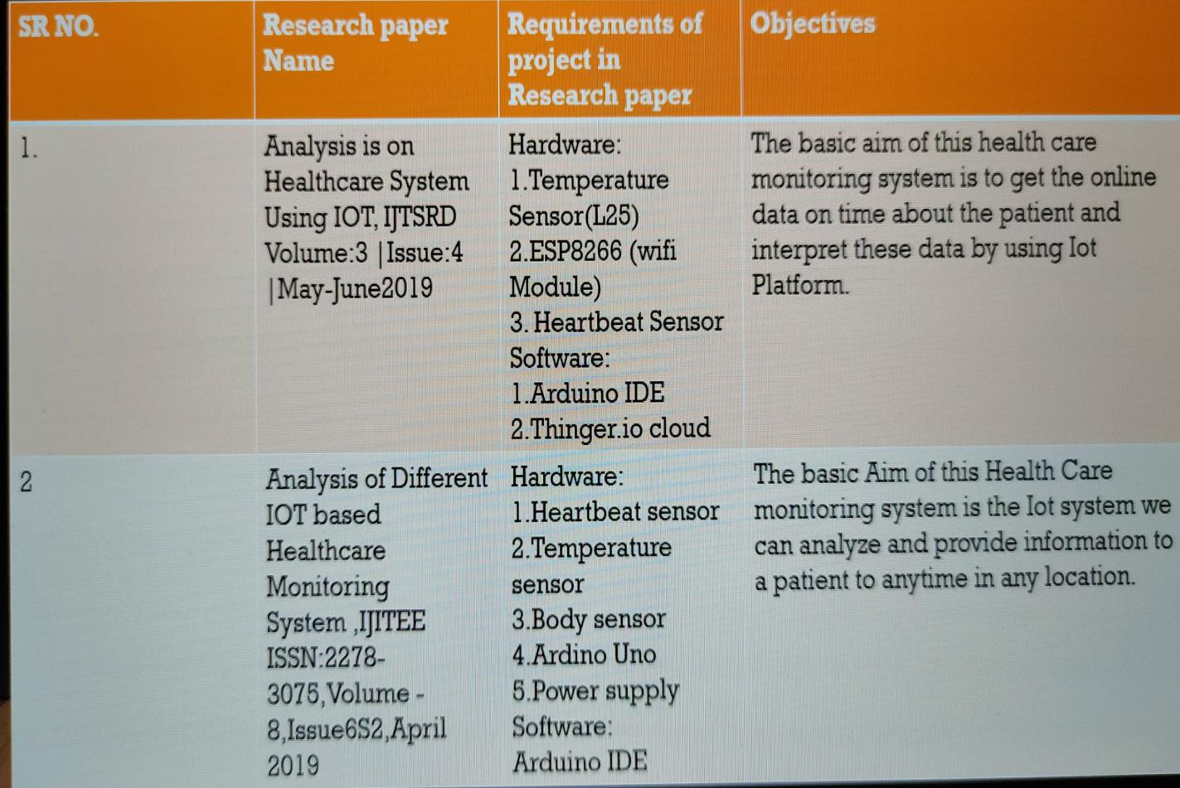

**Chapter 3**

**REQUIREMENTS AND ANALYSIS**

### 3.1 Problem Statement

Standing in queues and travelling a distance can be very hectic for getting small queries answered regarding academies and admission. AS everything is online these days there can be facility made available online for these purpose also. Interactive question - answering systems allows us to concentrate on the interaction between the user and the program and not just the question-answering. These systems allow either the user to drive the dialogue or the system to play a greater role by suggesting related materials or even refinements to a user’s query. When questions such as “Who is the principal of college? “and “What is the time table of FE?” are posed to a question-answering system, the program should return the answers it finds in documents rather than just returning a link to a document that may contain the answer as search engines do.

### 3.2 Requirements Specification

• Application must have a module for login using unique credentials of a patient for the doctor to monitor patient’s vital data.

• Application must have a module for login using unique credentials of a patient for

Guardian/Caretaker to monitor patient’s vital data.

• Location Tracking: Application must have track location option with which doctor or guardian can track location of the patient.

• Location sender: Hardware must have a GPRS module to fetch location coordinates which can be used to track location of patient.

• Messaging Service: Hardware must have GSM module which send’s SMS alert messages to doctor and guardians upon any emergencies. And application must send email alerts upon any emergencies

• Web application must be user friendly, simple and interactive.

• The user interface is designed in such way that novice users with little knowledge of web, should be able to access this application.

• Users are required to have some knowledge regarding Google maps.

### 3.3 Planning and Scheduling

Planning and scheduling is a complicated part of software development. Planning, for our purposes, can be thought of as determining all the small tasks that must be carried out in order to accomplish the goal. Planning also takes into account, rules, known as constraints, which, control when certain tasks can or cannot happen. Scheduling can be thought of as determining whether adequate resources are available to carry out the plan.

### 3.4 Software and Hardware Requirements

The software and hardware requirements necessary to implement the Healthcare Monitoring System using IOT are stated below

*Hardware Requirement:*

*• Microcontroller: Arduino Uno Board*

*• Sensors: Temperature(LM35), GSM Module, GPRS Module,*

*Heartbeat, BP*

*• Processor: Pentium IV or higher*

*• Processor speed: 1.6GHz*

*• RAM: 512 MB*

*• Disk Space: 250 MB or higher*

*Software Requirements:*

• Operating System: Windows 7 or higher

• Platform: IoT Cloud

• IDE: Arduino 1.8.4

• Database: MySQL

• Technologies used: Java, SQL

### 3.5 Preliminary Product Description

As main focus is monitoring the health of patient, Thus the system should always have a connection between the user and the Healthcare Monitoring System using IOT.The patients gets monitored by the system and also the system helps in speedy recovery of the patient. As per the Doctor’s observation to the readings of the patient, it easily helps them to treat the patients.

### 3.6 Conceptual Models

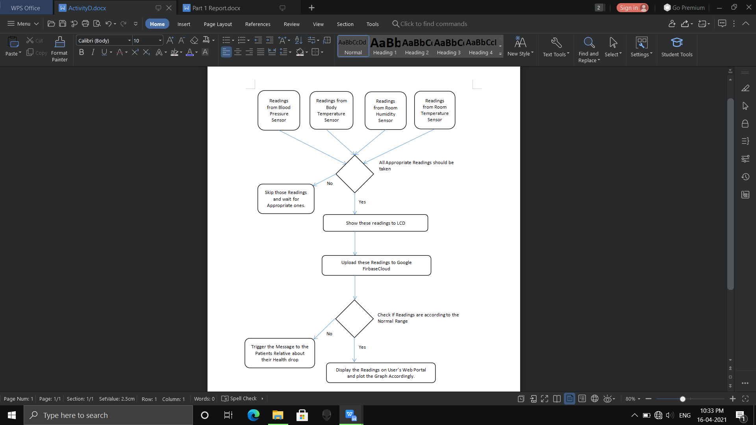

Figure 3.2: Activity Diagram

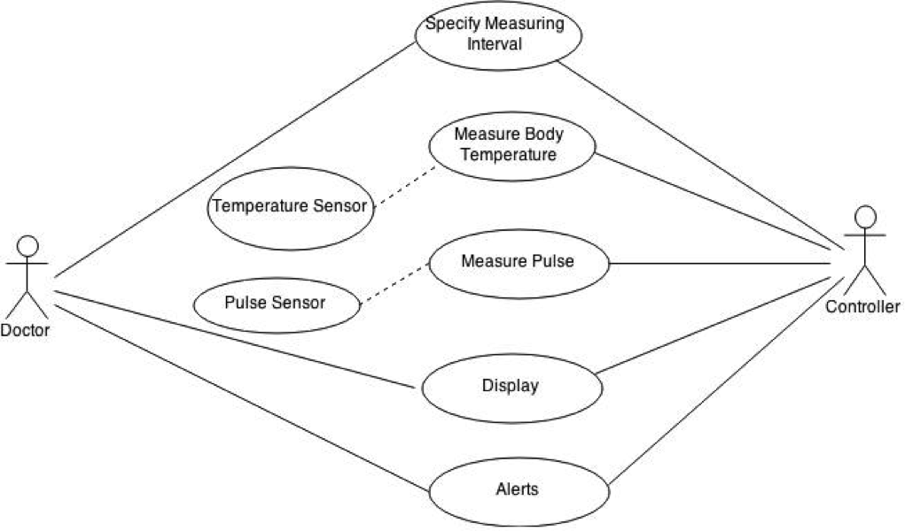

IoT

Figure 3.3: Use Case Diagram

**Chapter 4**

## SYSTEM DESIGN

Describes desired features and operations in detail, including screen layouts, business rules, process diagrams, pseudo code and other documentation.

### 4.1 Basic Modules

* Invalid Input:

Sometimes the user may use slangs or words that are not defined in English . Such non-standard phrases can affect the outcome and performance of the result of the Healthcare Monitoring System using IOT.

* Keyword Identification:

In some cases, there may be more than one keywords to the user query and the system will have to choose only one from them for further action. This may affect the overall accuracy of the response.

13

### 4.2 Security Issues

* Security testing refers to ensuring that the system will protect its data from unauthorized access and modification and that it will continue to behave as expected.
* Authorisation has been used to ensure that users have access to pages that they are supposed to of the system.
* The system shall not store or process any information about its users. Exceptions should be reported effectively to the user if they occur.

**Chapter 5**

## Implementation

### 5.1 Implementation Approaches

In this project The Arduino Uno will Read data from pulse Rate sensor ,Temperature Sensor and Humidity Sensor and send it to the smart healthcare portal where real time data will be displayed in Graphical Representation.

Historical Data is also stored and can be accessed using History page . The data sent from Arduino will be Checked against optimal body parameters.

Whenever the pulse rate or body Temperature or Humidity rises above or falls below the optimal parameter ,the Smart Health care Portal will Notify The User Of The Patient Condition Via . Push Notification. It has been developed with Arduino microcontroller connected with sensors which are attached to the patient. All the sensors and location data sent from microcontroller to MySQL database into the cloud. A doctor or guardian can log in to web portal to monitor patient’s data at any point in time. In case of emergencies, like temperature spike or heartbeat spike, an SMS and email alert sent to doctor and guardian’s mobile and email respectively. And at any point of time either a doctor or guardian can log into web portal with patient unique credentials and can track patient’s location which would help medical services to send appropriate help in case of emergencies.

17

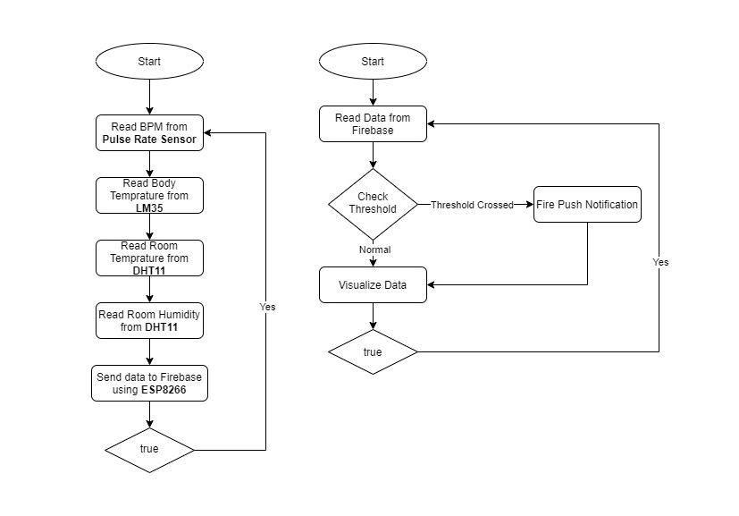

WorkFlow Diagram

5.1 **Connections:**

Step1 : Firstly ,connect the required components to Aurdino UNO using wires and breadboard as shown in figure.

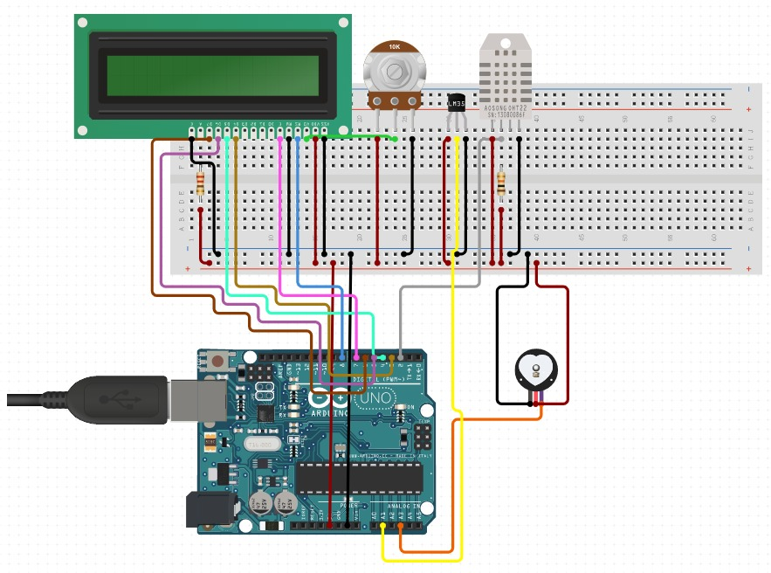

Step 2 : We need to connect the Wifi to patients mobile hotspot thus enabling the upload of data to the Google Firebase Cloud as shown in figure.

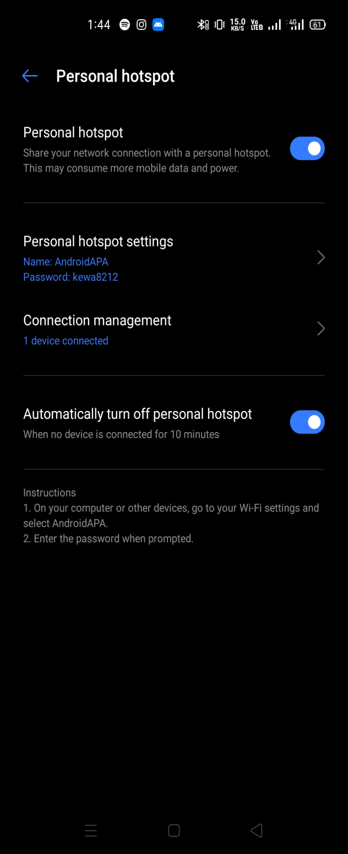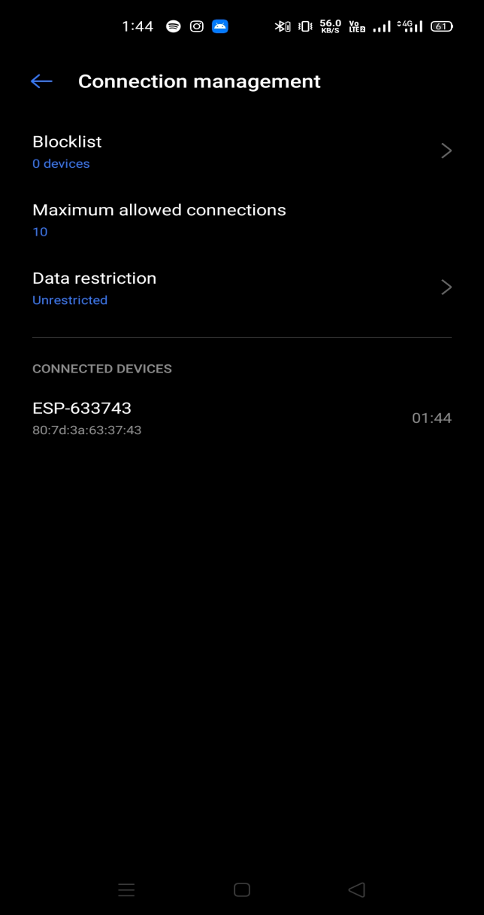

Step 3 : Log in to your Firebase Account and check whether the readings are uploaded on Cloud or not. Also User can check the history of each Sensors Data.

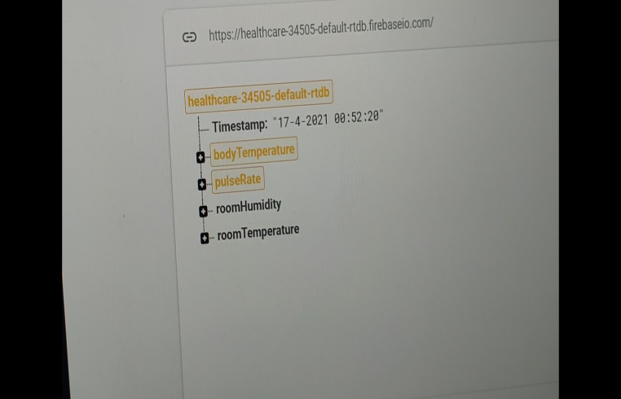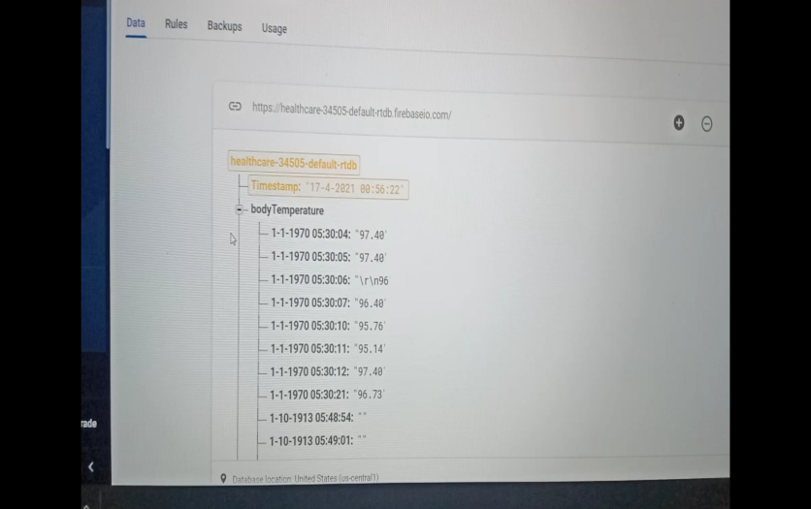

Step 4 : Log in to your Web Portal to check the detailed Graph Layout of Run time values.

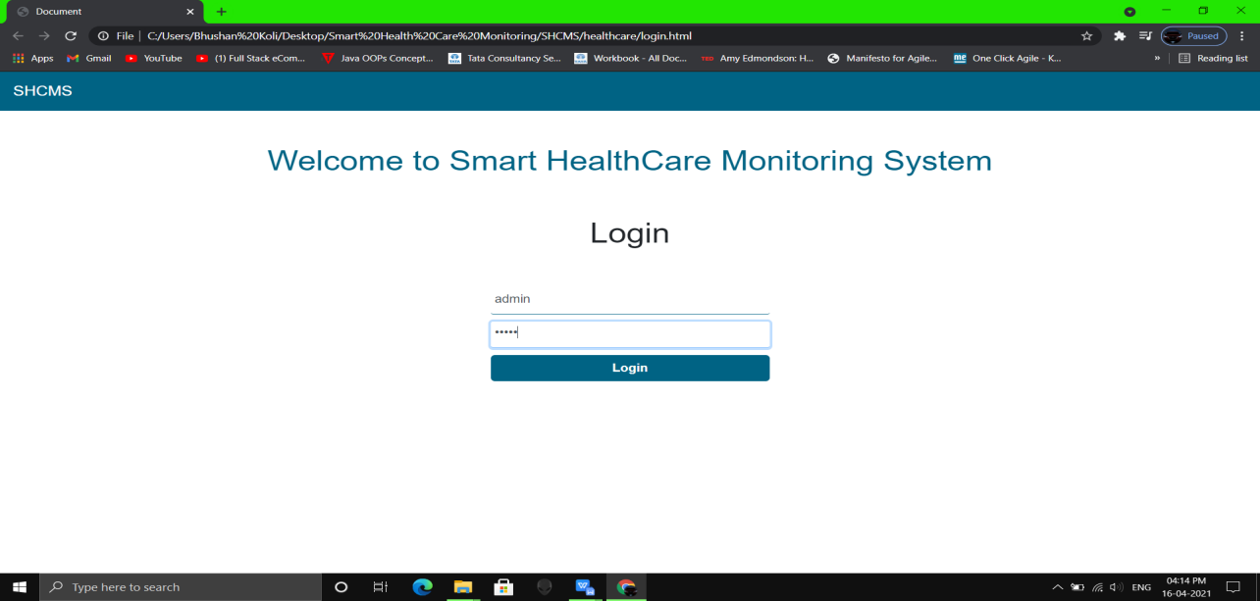

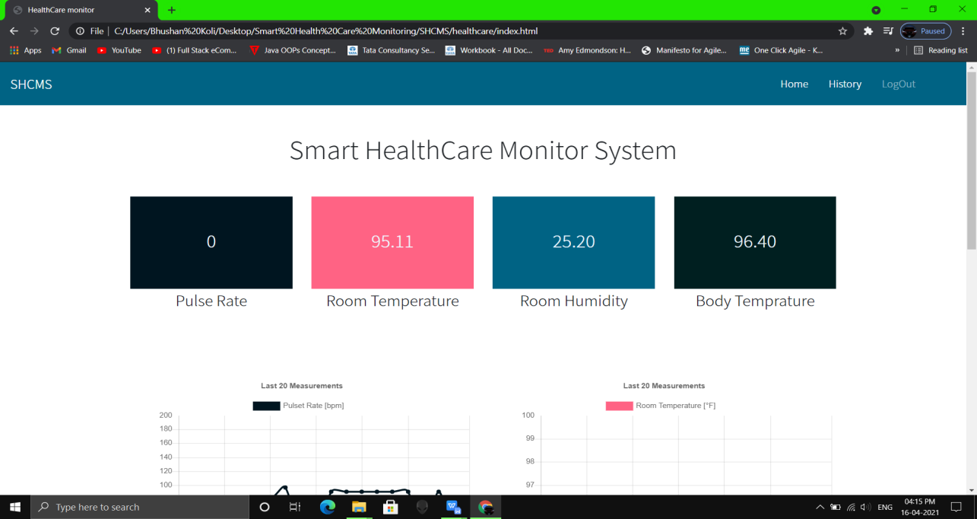

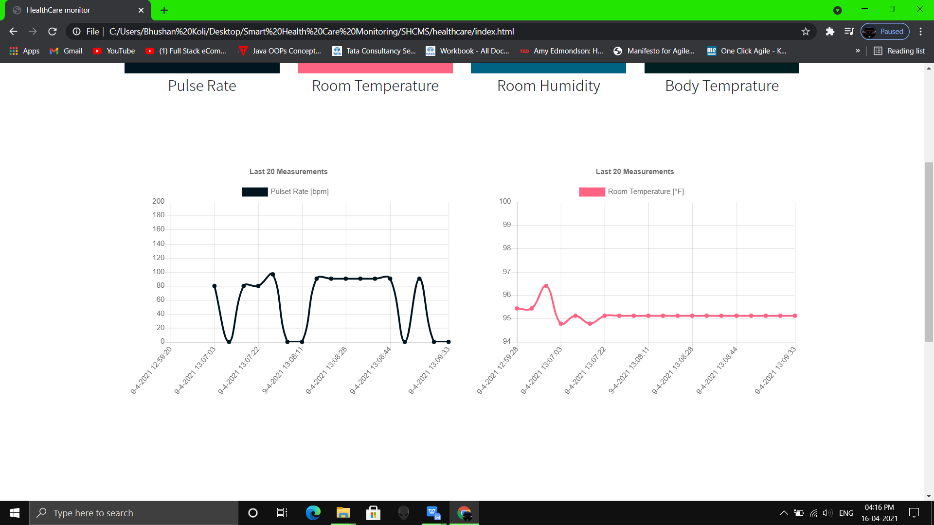

We can also check the History :

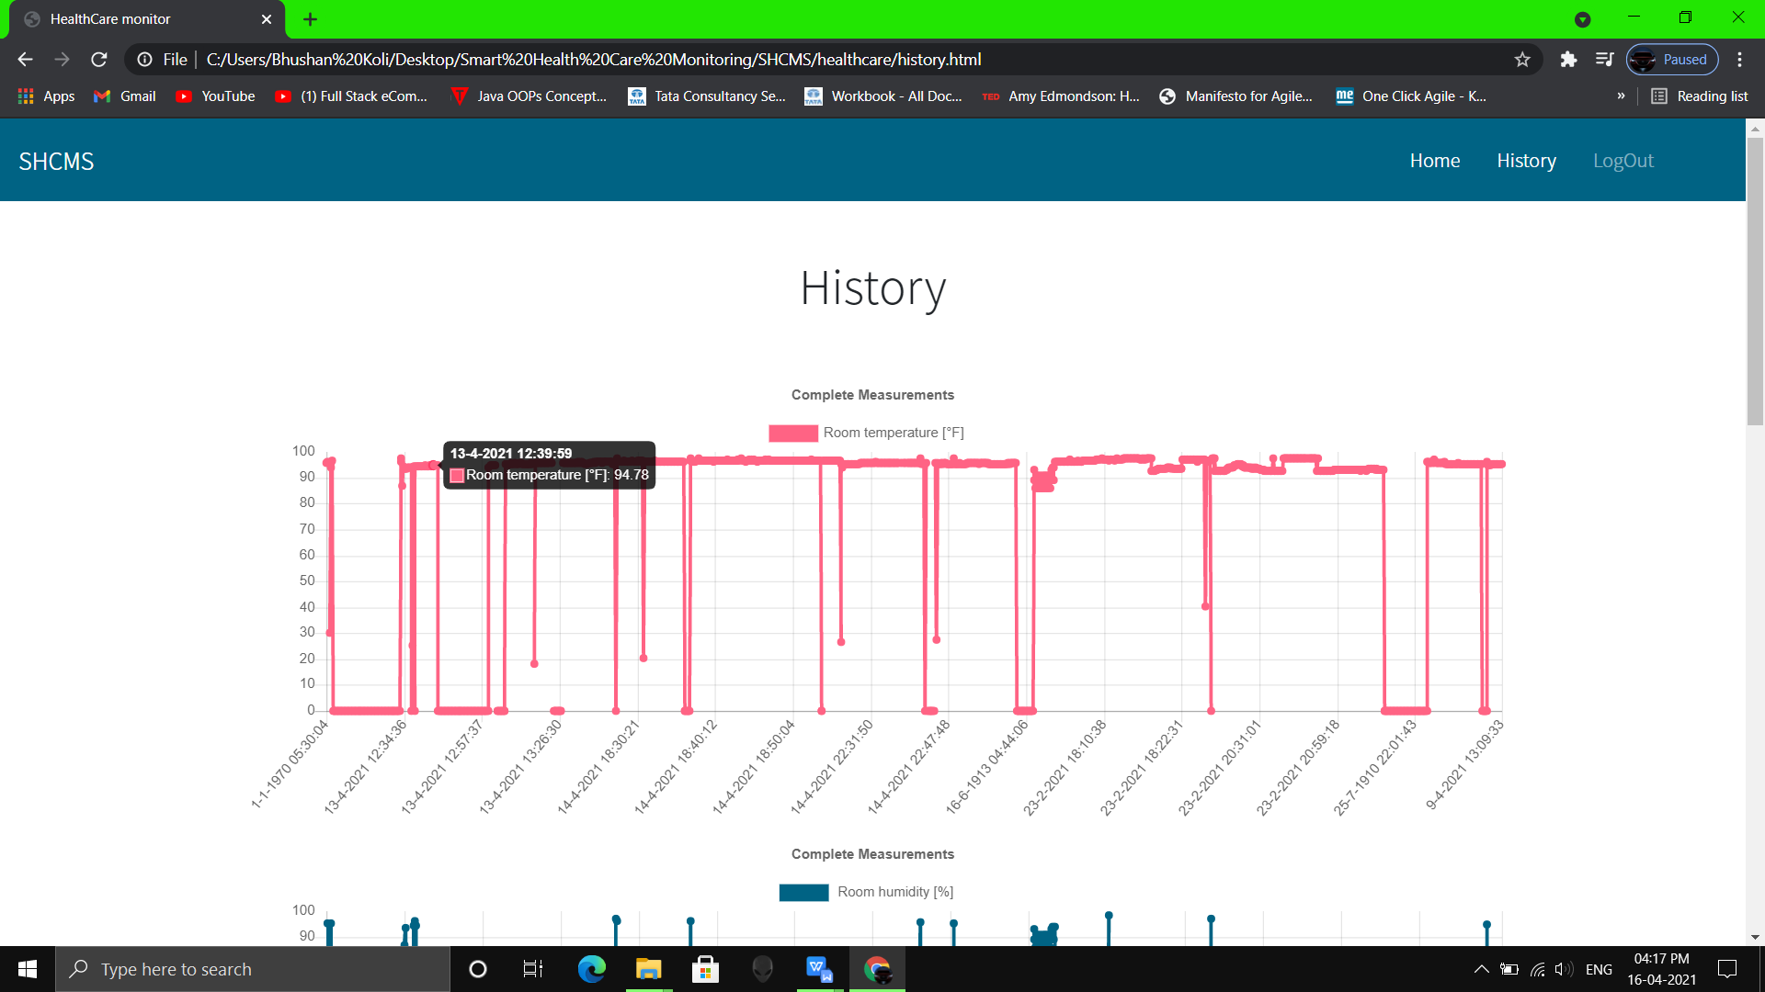

**Chapter 6**

## CONCLUSIONS

### 6.1 Conclusion

The proposed system of patient health monitoring can be highly used in emergency situations as it can be daily monitored, recorded and stored as a database. In future the IOT device can be combined with the cloud computing so that the database can be shared in all the hospitals for the intensive care and treatment.

### 6.2 Limitations of the System

* Security and privacy remain a major concern deterring users from using IoT technology for medical purposes, as[healthcare monitoring solutions](https://www.fpt-software.com/white-paper/healthcare-collaboration-monitoring-solutions/" \t "_blank) have the potential to be breached or hacked. The leak of sensitive information about the patient’s health and location and meddling with sensor data can have grave consequences, which would counter the benefits of IoT.
* Failure or bugs in the hardware or even power failure can impact the performance of sensors and connected equipment placing healthcare operations at risk. In addition, skipping a scheduled software update may be even more hazardous than skipping a doctor check-up.

25

Chapter 6. *CONCLUSIONS* 26

### 6.3 Future Scope of the Project

* Multiple parameter like retinal size ,age, and weight can be included as controlling parameter in the future .
* More than single patient at different place can be monitored using such system.
* Future Diagnosis can be performed via the same system.
* The interface can be designed to control which sensors can be used by consumers according to their needs.
* Website can be enhanced to perform several activities which include controlling the hardware, real-time graphs, history and analysis graphs to observe anomalies etc.

## Appendix A

### PROJECT REPORT STRUCTURE

The Healthcare monitoring system using IoT was researched, designed and presented the concept of the Internet of things. Personal physiological data from the patient is collected that simulates fall detection, heartbeat, temperature,BP, etc. sensors. The readings are collected in a simple cloud database and can be viewed remotely by a doctor or Healthcare giver. The data can also be used in research on medical issues affecting the elderly or chronically ill. On the security of the data, the database system is protected with Advanced Encryption Standard (AES). This generates the secret key which can be used to decrypt the patients’ records ensuring that only authorized personnel access the data. This safeguards the patients’ records from unauthorized users and hackers who may want to intercept.

27

## Bibliography

1. Dr.John Woods, Sameera A Abdul-Kader. Survey on Health Care Monitring System Design Techniques in Speech.
2. Dana Abu Ali, Nizar Habash. An Arabic Dialect Health Care Monitring System.
3. Mengting Yan , Paul Castro , Perry Cheng , Vatche Ishakian. Building a Health Care Monitring System with Serverless Computing
4. Bayan Abu Shawar, Eric Atwell.A Comparison between Alice and Elizabeth Heath Care Monitoring systems.
5. Nikita Hatwar, Ashwini Patil, Diksha Gondan. AI Based Health care monitoring System

Websites:

<http://en.wikipedia.org/wiki/Health> Care Monitoring System http://en.scientificcommons.org/43587573 [http://ezinearticles.com/?Artificial-Intelligence- Health](http://ezinearticles.com/?Artificial-Intelligence-Health) Care Monitorin System—Efficient-andReliableid=4658355